Refuse to disclose-G

b9. (Disability)

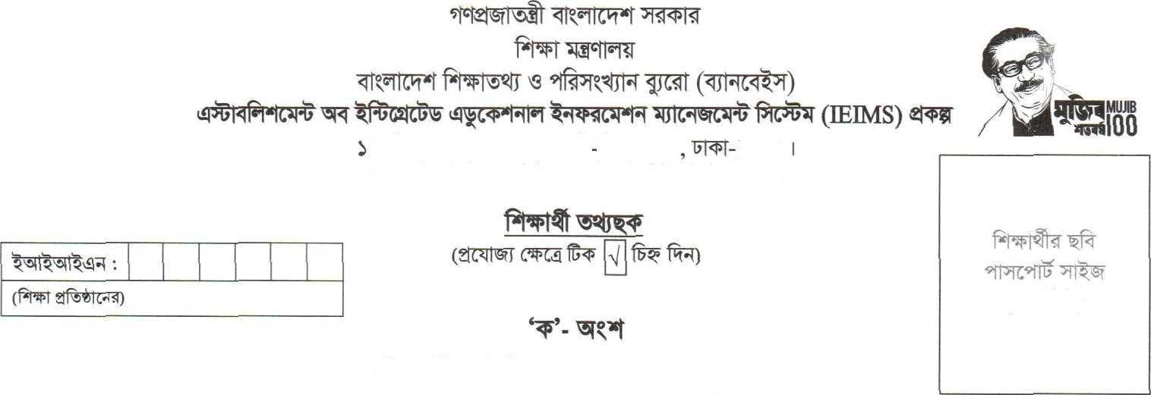

www.banbeis.gov.bd; [e-mail-info@banbeis.gov.bd](mailto:e-mail-info@banbeis.gov.bd)

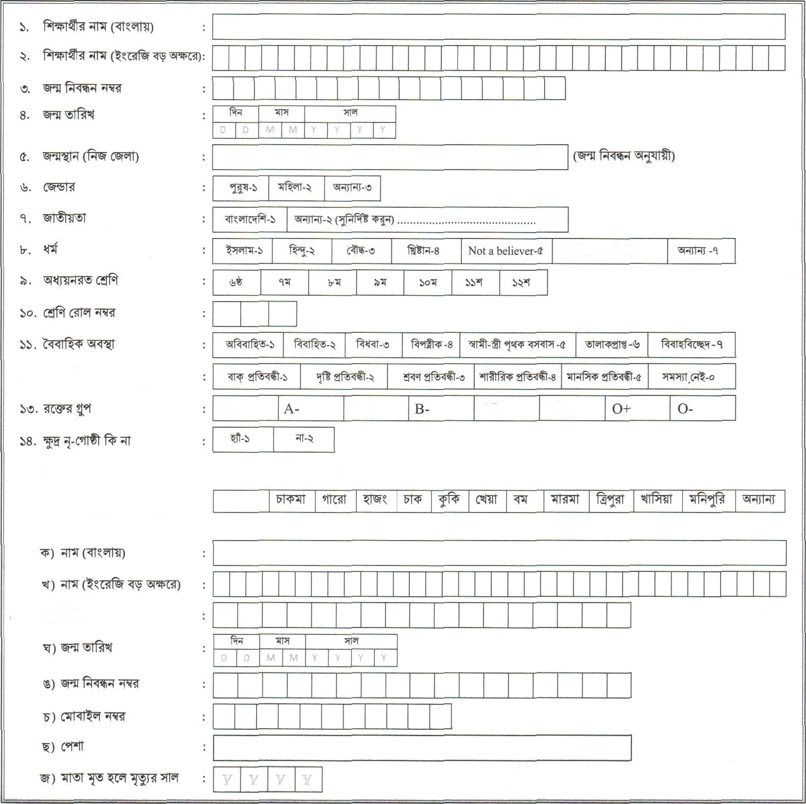

A+

B+ AB+ AB-

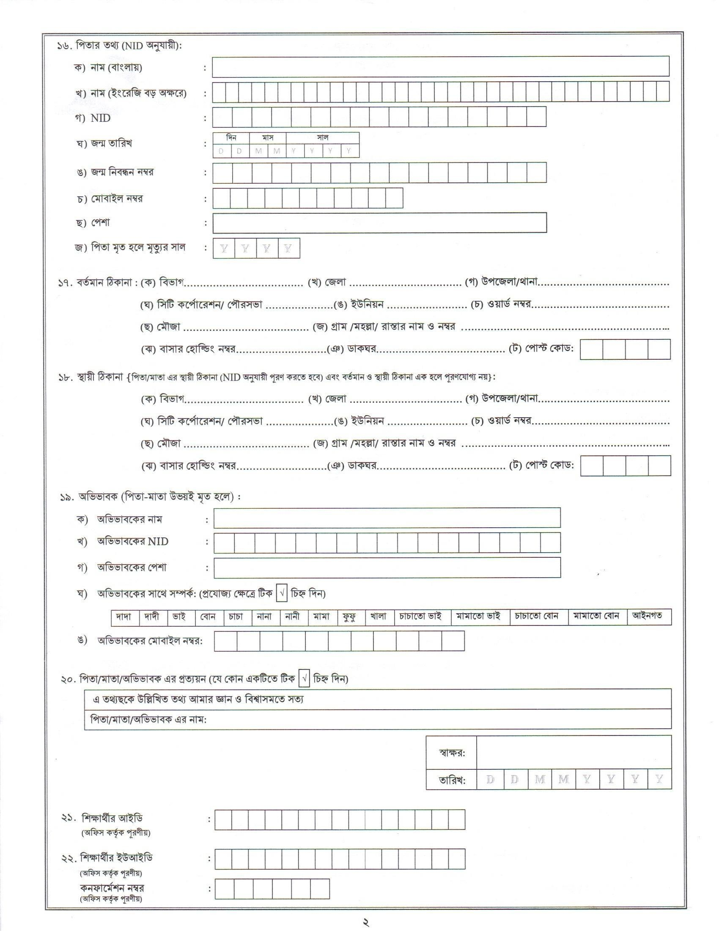

Thank you for using [www.freepdfconvert.com](http://www.freepdfconvert.com/) service!

Only two pages are converted. Please Sign Up to convert all pages. <https://www.freepdfconvert.com/membership>